Design Principles - Hollywood Principle
# Source: AI Source: Provided by: [Data Path: Persons Table -> ID Column: 1, Name_En Column: Motasem Essam] -> From: [ChatGPT] on [1/23/2026]
The Hollywood Principle is the guideline “Don’t call us, we’ll call you”. It encourages inversion of control, meaning higher-level components dictate the flow while lower-level components provide behavior when needed.
👉 Think of it like a movie director: actors don’t decide what happens — the director calls the shots.

🔑 Key Points
# Source: AI Source: Provided by: [Data Path: Persons Table -> ID Column: 1, Name_En Column: Motasem Essam] -> From: [ChatGPT] on [1/23/2026]
• Promotes inversion of control (IoC)
• Reduces dependencies between high-level and low-level modules
• Supports modular, flexible, and extensible designs
• Commonly used in frameworks, callbacks, and event-driven systems

❌ Bad Example
# Source: AI Source: Provided by: [Data Path: Persons Table -> ID Column: 1, Name_En Column: Motasem Essam] -> From: [ChatGPT] on [1/23/2026]
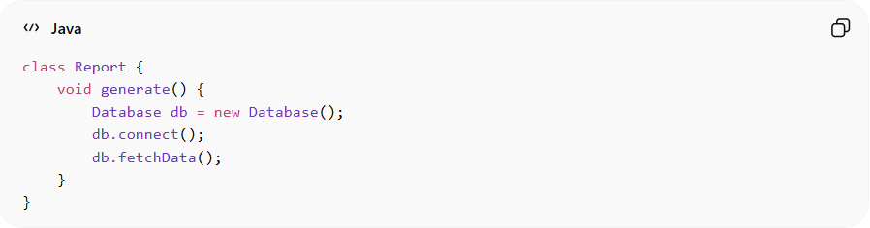
class Report {
void generate() {
Database db = new Database();
db.connect();
db.fetchData();
}
}
Problems:
• Report class directly controls low-level modules (Database)
• Tightly coupled → hard to test or replace Database
• Violates inversion of control
• Difficult to extend or reuse

✅ Good Example
# Source: AI Source: Provided by: [Data Path: Persons Table -> ID Column: 1, Name_En Column: Motasem Essam] -> From: [ChatGPT] on [1/23/2026]
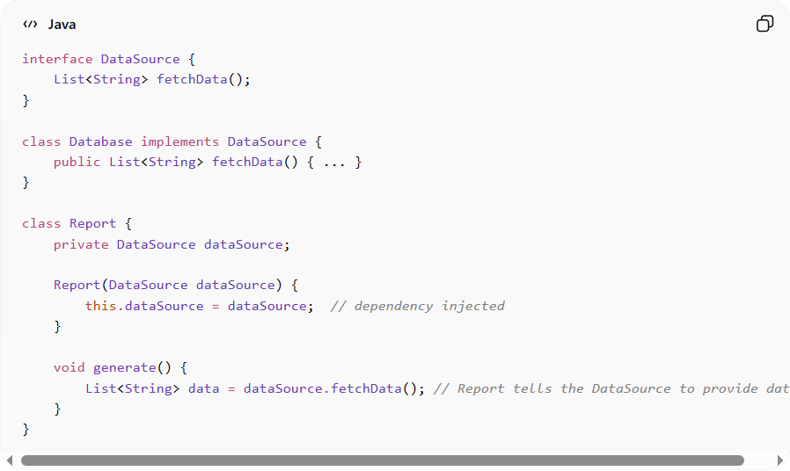
interface DataSource {
List<String> fetchData();
}

class Database implements DataSource {
public List<String> fetchData() { ... }
}

class Report {
private DataSource dataSource;

Report(DataSource dataSource) {
this.dataSource = dataSource; // dependency injected
}

void generate() {
List<String> data = dataSource.fetchData(); // Report tells the DataSource to provide data
}
}
Benefits:
• High-level modules no longer control low-level modules
• Easier to test using mocks or stubs
• Supports flexible architecture and framework integration
• Decouples modules for easier maintenance and evolution

⚡ When to Apply
# Source: AI Source: Provided by: [Data Path: Persons Table -> ID Column: 1, Name_En Column: Motasem Essam] -> From: [ChatGPT] on [1/23/2026]
• In frameworks, libraries, or event-driven systems
• When designing modular, testable, and flexible software
• Works best with Dependency Injection and Inversion of Control
• Combine with SOLID principles for robust architecture

